Interrogating Space
Workshop Guide

Grid Iron Theatre Company, The Envelope Room & Ephemera Collective is collaborating to host 2 days of workshops exploring approaches to designing found spaces. This is a fantastic opportunity for anyone with experience or interest in the areas of site responsive theatre, installation art and spatial design to discover different approaches to interact creatively with space. We are delighted to welcome the Ephemera Collective to Scotland from Serbia and are excited to host this unique opportunity for theatre designers, theatre makers, architects and interested artists to come together to look at spatial design together.

--------------------------------
Workshop Leaders

Ben Harrison is Co-Artistic Director of Grid Iron. He has taught site-responsive theatre in Lebanon, Jordan, Ireland, the Netherlands, New Zealand, Portugal, South Africa, Scotland and England. www.gridiron.org.uk www.benharrison.info

Miljana Zeković and Višnja Žugić are co-founders of Ephemera Collective, based in Novi Sad, Serbia. The collective ventures into performance, theatre, storytelling, visual arts, phenomenology and social science, in order to detect tools and acquire skills necessary for the establishment of an architectural alternative. www.ephemeracollective.org www.behance.net/ephemera

---------------------------------------
Workshop Descriptions

The workshops will take place in the former Great Junction Street Public School Baths, Edinburgh.

Friday 3rd March
10am – 1pm
Listening to the Space
Ben Harrison, Co-Artistic Director of Grid Iron will lead a half-day workshop entitled Listening to The Space, which through a series of practical, visual and sensual exercises interrogates the space we are working in to bring out its unique character in relation to the personalities of the workshop participants.

1pm – 2pm
Lunch (provided)

2-6pm
The Water Inside
In the second phase of this creative process participants will be encouraged to search for ‘The Water Inside’ together with Miljana Zeković and Višnja Žugić, members of Ephemera Collective, Serbia. Through detecting, embracing and creatively developing potentials of space, the group will be introduced to specific method of delayering of spatial memory, narratives and ambience.

6pm (optional)
Light refreshments and informal reflections on the day

Saturday 4th March
10am – 6pm (lunch provided)
Today we will focus on responses to the previous days’ workshops and both Ben Harrison & Ephemera will lead the day. By joining and overlapping the experiences from both workshops, participants’ will be, guided towards a creative engagement with the accumulated qualities of the space. Creating an intervention that will bring out a true nature of Space as a Protagonist, the workshop series will result in a true and practical interrogation of the site. There will time built in to reflect on the workshops and enquire about anything that may have been provoked through the sessions.

---------------------------------------
How To Apply

We have space for a maximum of 12 participants. The workshops are aimed at designers, theatre makers but may also be of interest to installation artists or architecture graduates also. We regret this workshop is not open to performers or students.

Interested applicants should send a CV and a short explanation of why they wish to take part to hello@enveloperoom.org.uk by midnight on Sunday 5th February. Participants will be selected to ensure that we have a good mix of experience and disciplines represented. All applicants will be notified by Wednesday 8th February.

Please note: There is no cost to attend the workshop. We will provide lunch on both days but are unable to cover travel, however please contact us if this is a barrier for you.

We look forward to hearing from you!

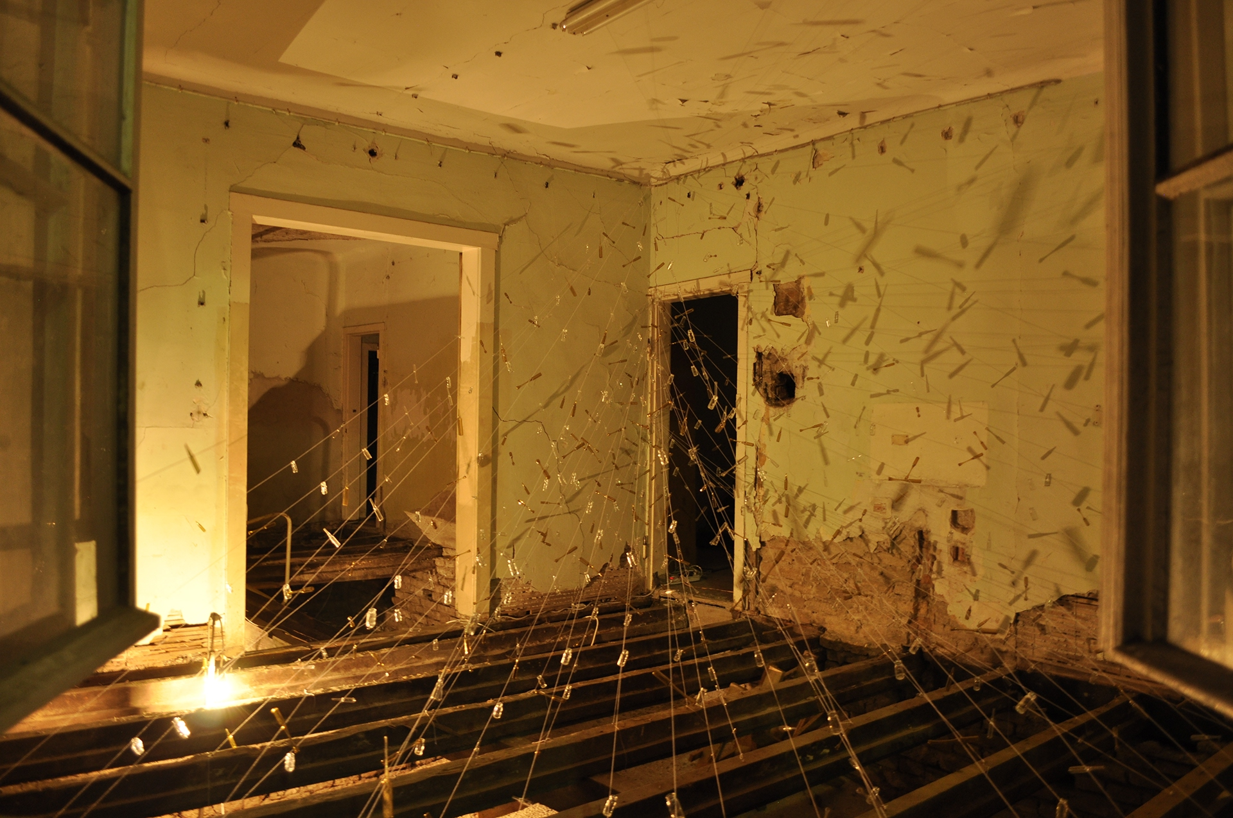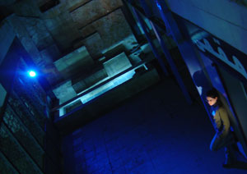
Ephemera Collective: Adolf (2015). Grid Iron in Lebanon 2004
Photo: Bojan Stojković and Igor Vukičević Photo: British Council

